**How to submit an assignment**

In order to submit an assignment, locate and click on ‘Bi-Weekly Assignment 1’ under week 2

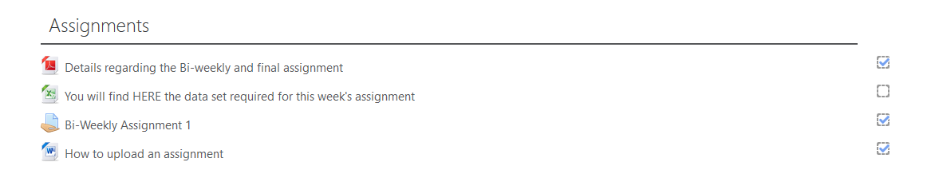

The following screen appears: To submit an assignment click on ‘Add submission’

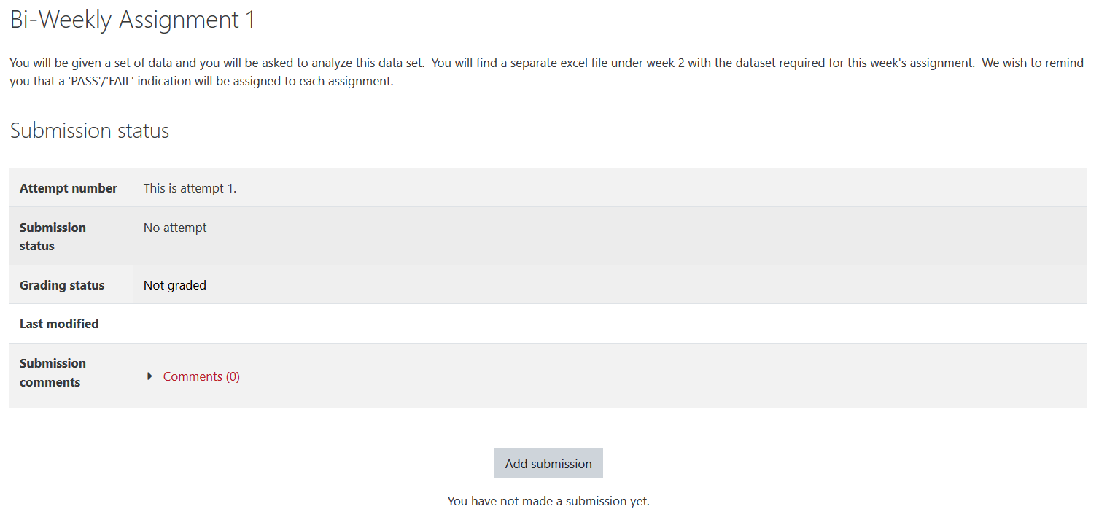

In the following screen, you can drag and drop your assignment.

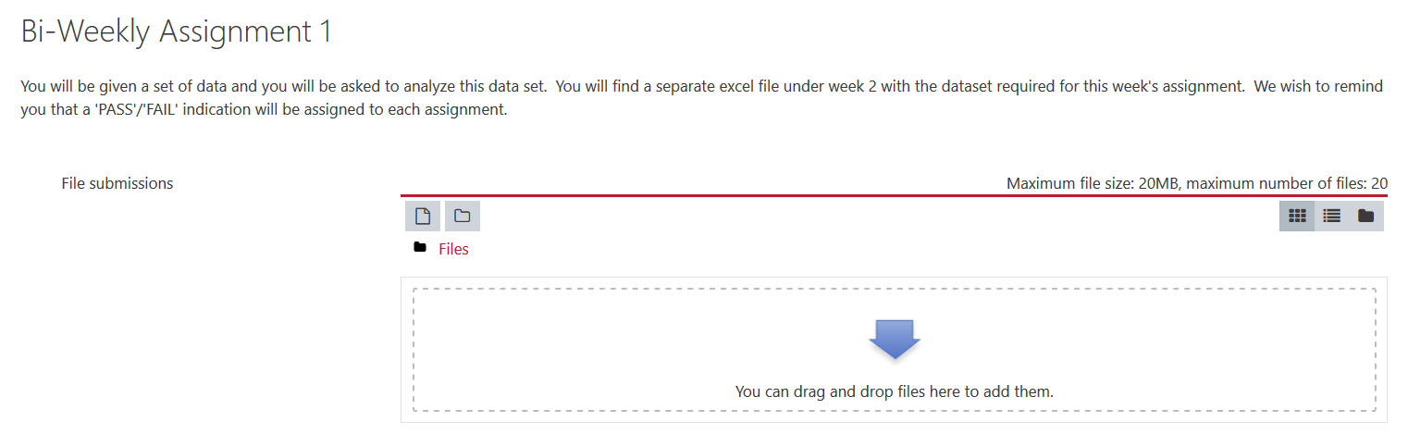

Alternatively, you can browse for a file, by clicking on the relevant icon indicated.



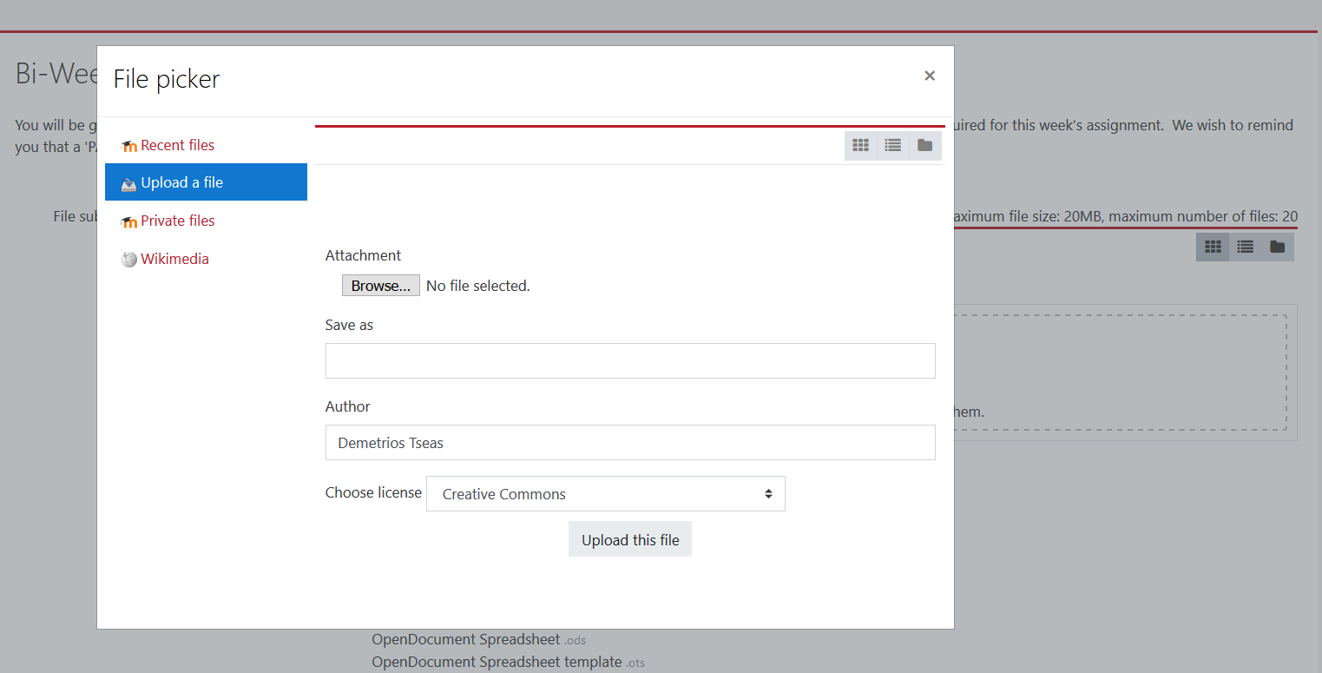

Drag and drop or upload your document. In the following screen, I have uploaded a relevant document for training purposes.

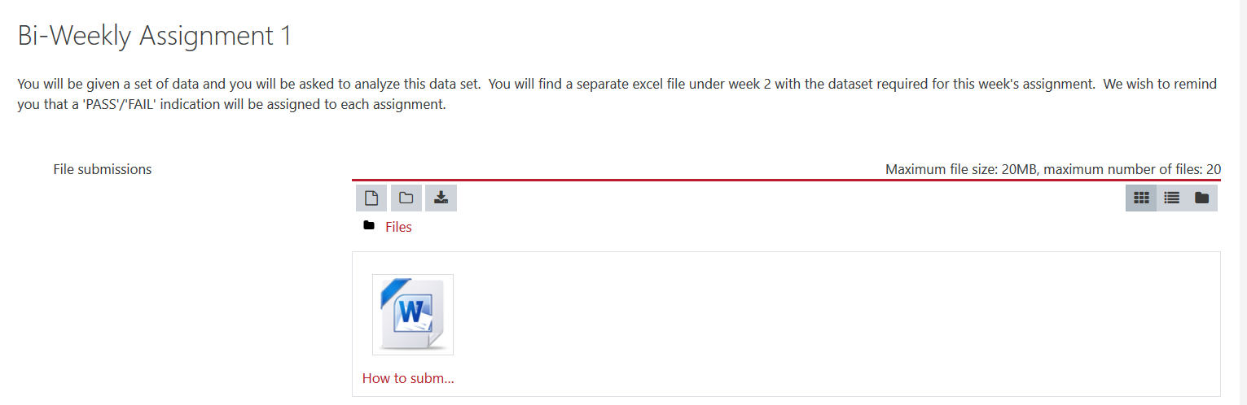

A variety of accepted file types is listed. Then click on ‘Save Changes’

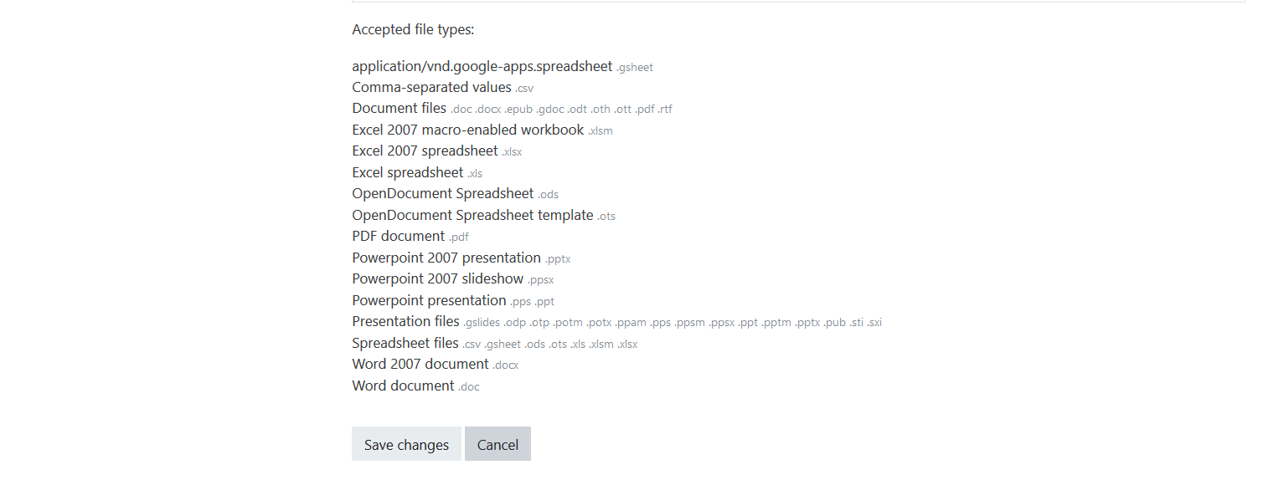

**Important:** Please notice that your assignment still remains in ‘draft’ mode. You can still ‘Edit’ or ‘Remove’ your submission.

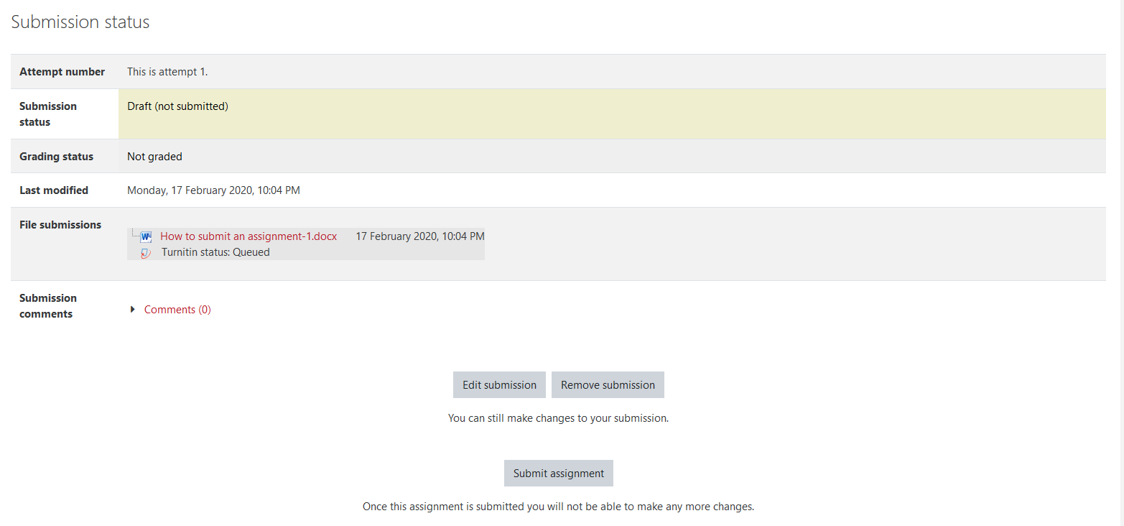

In case you wish to Remove your submission the following window will appear.

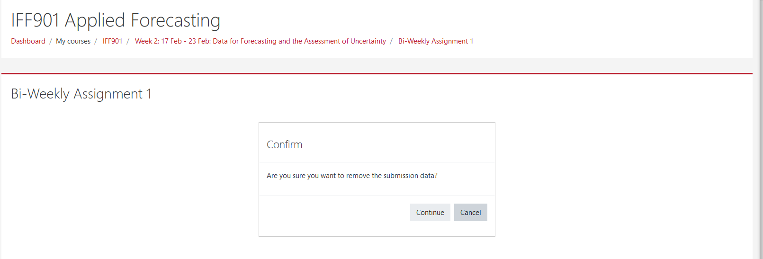

When everything is OK then press ‘Submit assignment’ to finalize submission.



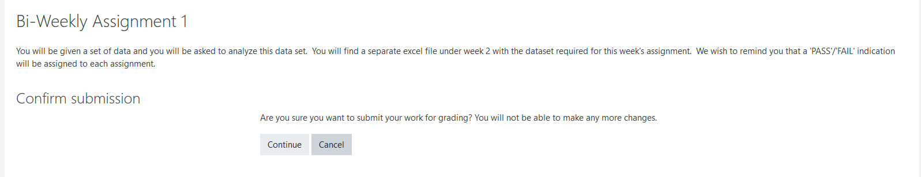

Notice that the submission status has now changed to: submitted for grading.

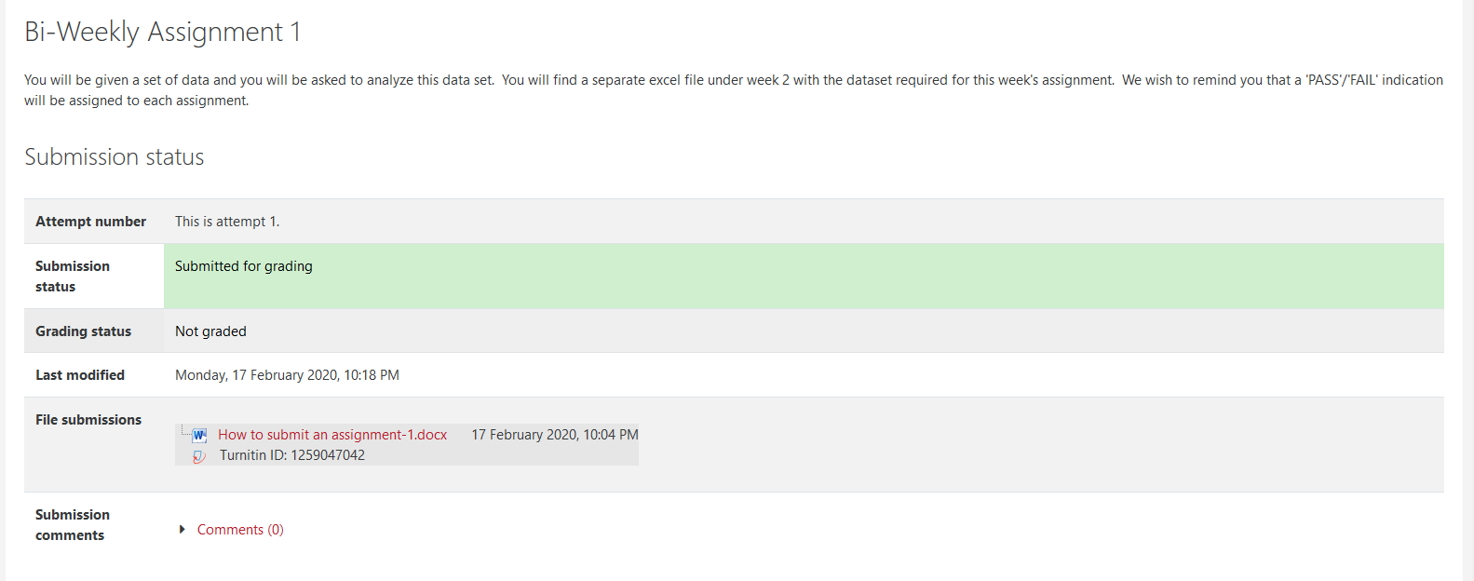

Thank you for your attention. If you continue having any other questions please upload them in the forum.

…..///…..